 **MINISTRY OF EDUCATION AND TRAINING**

**FPT UNIVERSITY**

Capstone Project Document

**Timetable Management Support Tools**

|  |  |
| --- | --- |
| **Group 6** | |
| **Group member** | Lu Quoc Cuong - SE60940  Pham Tran Tuan Vu - SE61063  Ho Thien Nguyen - SE60850  Ha Trong Trung – SE60597 |
| **Supervisor** | Mr. Kieu Trong Khanh |
| **Ext. Supervisor** | N/A |
| **Capstone Project code** | TMST |

-Ho Chi Minh City, 05/01/2015-

# Table of Contents

Table of Contents 3

List of Tables 5

List of Figures 6

Definitions, Acronyms, and Abbreviations 8

F. Software User’s Manual 9

1. Installation Guide 9

1.1 Setting up environment at server side 9

1.2 Deployment at server side 9

1.3 Setting up the environment at client side 15

1.4 Synchronize data between local and server 15

2. User Guide 15

2.1 Import plan 15

2.2 Import class 16

2.3 Import Schedule 17

2.4 Suggest Temporary 18

2.5 Edit Temporary Data 19

2.6 View Temporary Data 20

2.7 Add Course 21

2.8 Export to Excel 22

2.9 Create Complete 23

2.10 Show Complete 24

2.11 Edit Complete 25

2.12 Export Timetable 30

2.13 Mail Timetable 30

2.14 Suggest Guide Project Schedule 31

2.15 Manage Schedule 32

2.16 Edit Guide Project Schedule 33

2.17 Export Guide Project Schedule 36

2.18 Mail Guide Project Schedule 37

2.19 Manage Room Usage 37

2.20 Edit Room Usage 38

2.21 Export Room Usage 39

2.22 Calculate Timekeeping 39

2.23 Email Configuration 40

2.24 Synchronize Configuration 40

G. Appendix 44

# List of Tables

No table of figures entries found.

# List of Figures

Figure 1: Set up system variable 10

Figure 2: Set up JRE_HOME 10

Figure 3: Setup CATALINA_HOME 11

Figure 4: Connect SQL Server 12

Figure 5: Create Database Success 13

Figure 6: Start server 14

Figure 7: Change the connection string 14

Figure 8: Run application 15

Figure 9: Import plan 16

Figure 10: Import class 17

Figure 11: Import Schedule 18

Figure 12: Suggest Temporary 19

Figure 13: Edit Temporary Data 20

Figure 14: View Temporary Data 21

Figure 15: Add Course 22

Figure 16: Export to Excel 23

Figure 17: Create Complete 24

Figure 18: Show Complete 25

Figure 19: Add Time Table 26

Figure 20: Move Day 27

Figure 21: Change Slot 28

Figure 22: Update Instructor 29

Figure 23: Adjust 12 week 30

Figure 24: Export Timetable 30

Figure 25: Mail Timetable 31

Figure 26: Suggest Guide Project Schedule 32

Figure 27: Manage Schedule 33

Figure 28: Change Day 34

Figure 29: Change Week 35

Figure 30: Update Multiple Day 36

Figure 31: Export Guide Project Schedule 36

Figure 32: Mail Guide Project Schedule 37

Figure 33: Manage Room Usage 38

Figure 34: Edit Room Usage 38

Figure 35: Export Room Usage 39

Figure 36: Calculate Timekeeping 39

Figure 37: Email Configuration 40

Figure 38: Get JSON setting - Step 1 – Create Project 41

Figure 39: Get JSON setting - Step 2, 3, 4 – Setting name of project 41

Figure 40: Get JSON setting – Step 5, 6, 7, 8 – Enable Calendar API 42

Figure 41: Get JSON setting – Step 9, 10, 11, 12, 13 – Create Client ID 42

Figure 42: Get JSON setting – Step 14 – Download JSON file 42

Figure 43: Get JSON setting – Content of JSON file 43

Figure 44: Synchronize Configuration 43

# Definitions, Acronyms, and Abbreviations

|  |  |
| --- | --- |
| **Name** | **Definition** |
| TMST | Timetable Management Support Tools |

# Software User’s Manual

## Installation Guide

### Setting up environment at server side

The web application must be installed into the server side:

#### Hardware requirements

Personal computers for developing with the minimum configuration:

* Processor: CPU Intel Xeon E3 2.0GHz.
* Memory: minimum 2GB of RAM.
* Available Disk Space: minimum 30GB hard disk (10GB install Window server).
* Wi-Fi Internet (> 2Mbps).

#### Software requirements

* Web Server:
* Apache Tomcat 8.0.34: <http://tomcat.apache.org/download-80.cgi>
* Java Runtime Environment 8 update 45 (jre-8u45) or above: <http://www.oracle.com/technetwork/java/javase/downloads/jre8-downloads-2133155.html>
* Microsoft Windows Server 2008: operating system.
* SQL Server 2008 R2: used to create and manage the database for web application.

### Deployment at server side

#### Set up system variable.

**Control Panel\All Control Panel Items\System\Advanced system settings**, in “Advanced” tab select **Environment variables**… button.

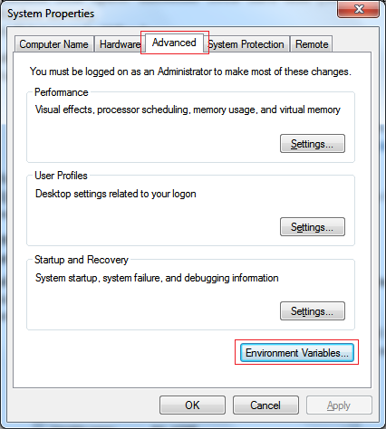

Figure : Set up system variable

* Set up JRE_HOME:
  + Click “New…” button in User variables for Admin and fill variable name with JRE_HOME and variable value with your JRE path installed on your computer.

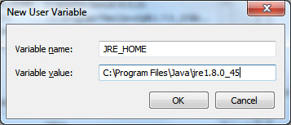

Figure : Set up JRE_HOME

* Setup CATALINA_HOME:
  + Click “New…” button in System variables and fill variable name with CATALINA_HOME and variable value with your Tomcat server path on your computer.

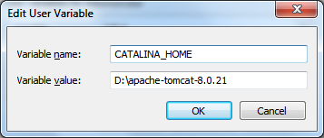

Figure : Setup CATALINA_HOME

#### Prepare deployment package

* Copy the deployment package (SyncCalendar.war) to a webapps folder on the Tomcat server.

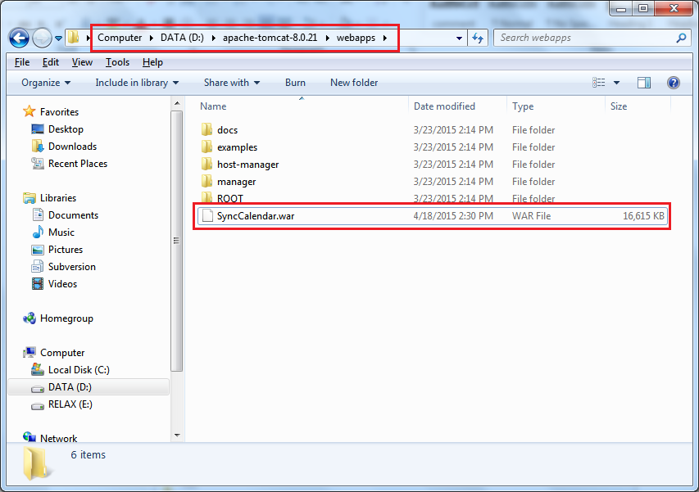

#### Deploy database

Open Microsoft SQL Server Management Studio.

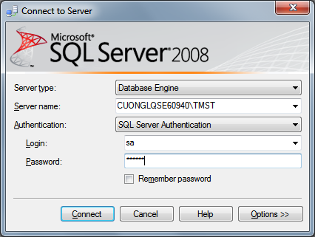

Figure : Connect SQL Server

Open and execute the createDB.sql file

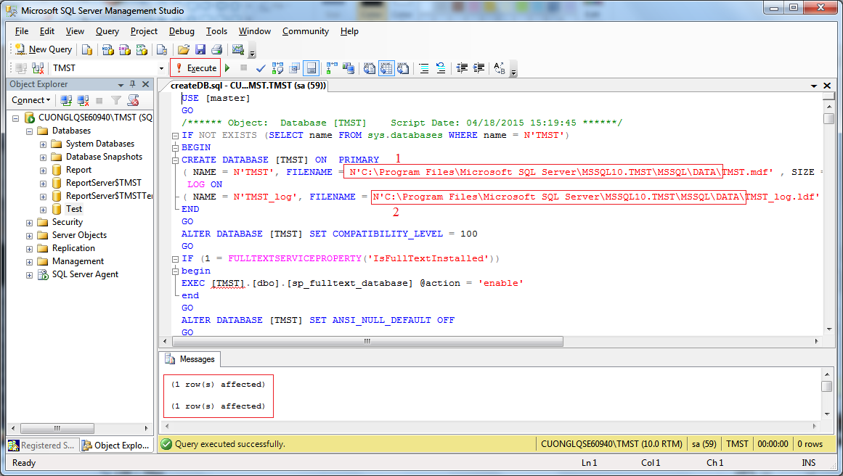

* Replace 1 and 2 with Microsoft SQL Server local installed path

[local_path]/MSSQL\DATA

* Run script file by click Execute
* Program notify (1 row(s) affected) and database TMST will be created.

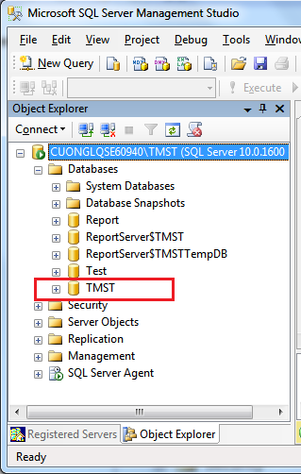

Figure : Create Database Success

#### Deploy web application on server

* Start server to unpacked SyncCalendar.war.

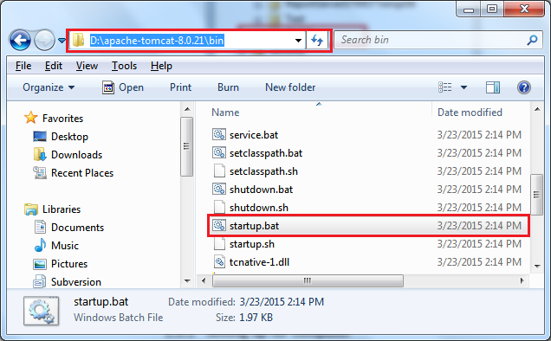

Figure : Start server

* Change the connection string in “D:\apache-tomcat-8.0.21\webapps\SyncCalendar\WEB-INF\classes\ DBConfig.properties”

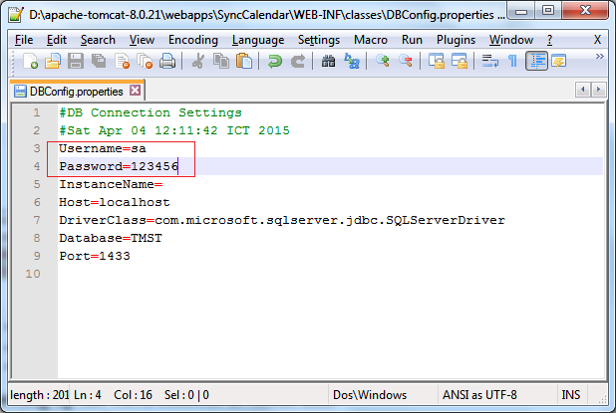

Figure : Change the connection string

* Restart server for the changes to take effect.
* Open localhost on server to see if deployment successful or not.
* Ex: http://localhost:8080/SyncCalendar/

### Setting up the environment at client side

#### Software requirements

* Java Runtime Environment 8 update 45 (jre-8u45) or above.

<http://www.oracle.com/technetwork/java/javase/downloads/jre8-downloads-2133155.html>

* SQL Server 2008 R2: used to create and manage the database for web application.

#### Deploy database

Reference **1.2.3 - Deploy database**

#### Run application

* Unzip the file TMST.rar
* Run “TMST.exe” file

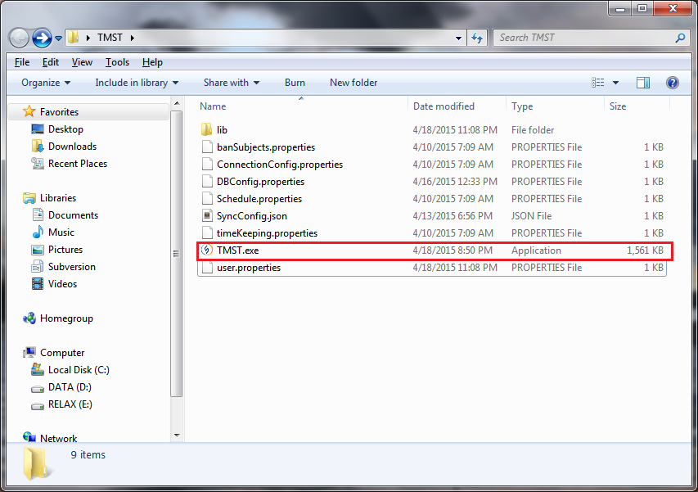

Figure : Run application

### Synchronize data between local and server

Reference: <http://vn.tips4admin.com/post/2011/04/16/%C4%90ong-bo-hoa-du-lieu-tren-2-Database-Server-dung-SQL-Server-2008.aspx>

## User Guide

### Import plan

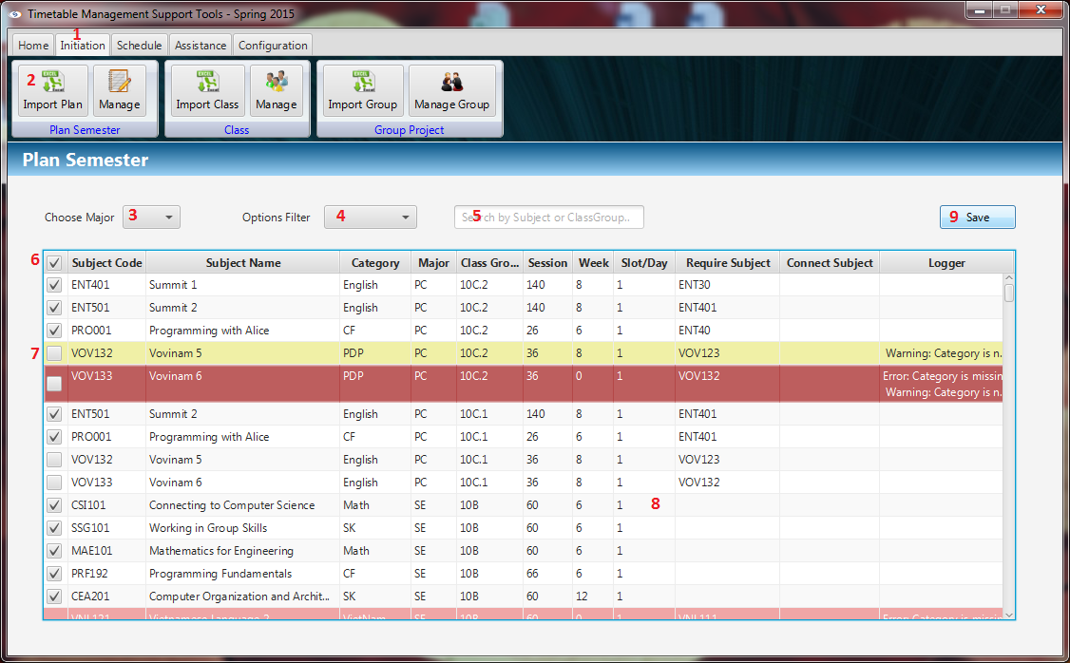

Figure : Import plan

|  |  |
| --- | --- |
| **Step** | **Description** |
| 1 | Click “Initiation” Tab |
| 2 | Click “Import Plan” button |
| 3 | Click major combo box to filter by major |
| 4 | Click options combo box to filter by another |
| 5 | Fill the text field to search by subject or class group |
| 6 | Stick the checkbox to select row on table |
| 7 | Stick to top checkbox to check all rows |
| 8 | Double clicks on row to edit information |
| 9 | Click “Save” button to save imported data |

### Import class

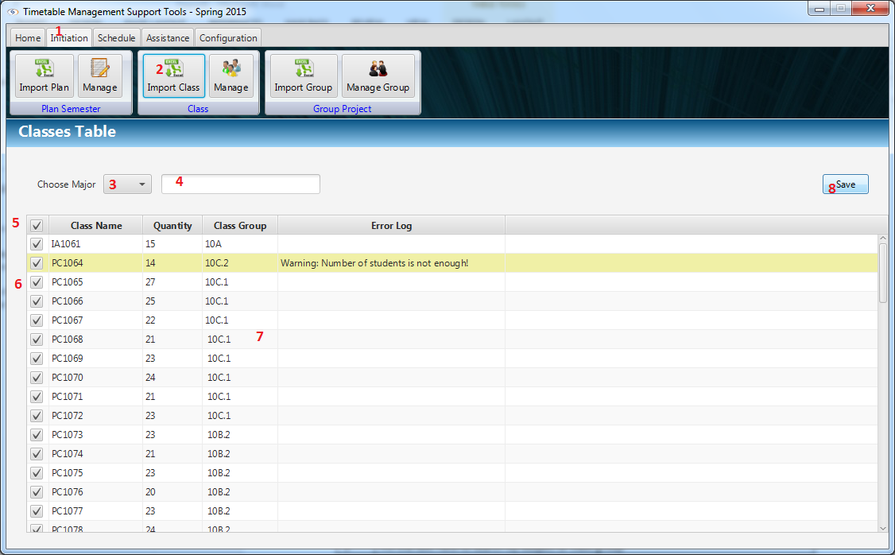

Figure : Import class

|  |  |
| --- | --- |
| **Step** | **Description** |
| 1 | Click “Initiation” Tab |
| 2 | Click “Import Class” button |
| 3 | Click major combo box to filter by major |
| 4 | Fill the text field to search by subject or class group |
| 5 | Stick the checkbox to select row on table |
| 6 | Stick to top checkbox to check all rows |
| 7 | Double clicks on row to edit information |
| 8 | Click “Save” button to save imported data |

### Import Schedule

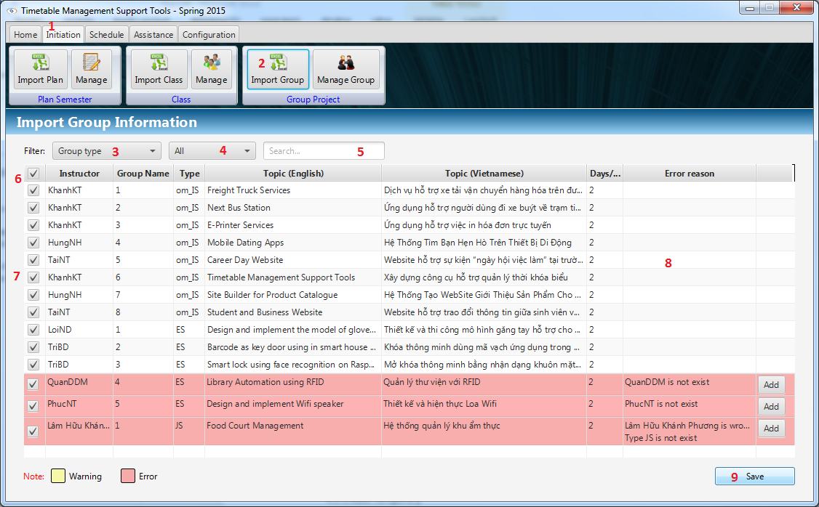

Figure : Import Schedule

|  |  |
| --- | --- |
| **Step** | **Description** |
| 1 | Click “Initiation” Tab |
| 2 | Click “Import Schedule” button |
| 3 | Click filter combo box to filter by group type |
| 4 | Click options combo box to filter by another options |
| 5 | Fill the text field to search |
| 5 | Click “Add” button to add instructors |
| 6 | Stick the checkbox to select row on table |
| 7 | Stick to top checkbox to check all rows |
| 8 | Double clicks on row to edit information |
| 9 | Click “Save” button to save imported data |

### Suggest Temporary

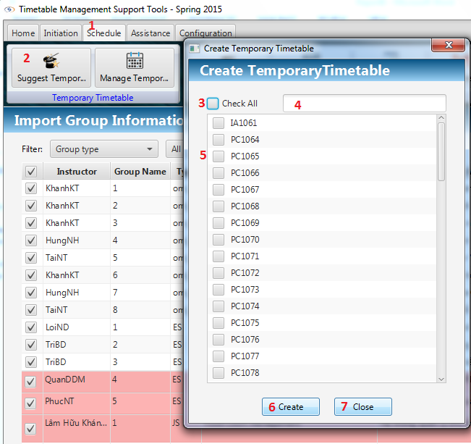

Figure : Suggest Temporary

|  |  |
| --- | --- |
| **Step** | **Description** |
| 1 | Click “Schedule” Tab |
| 2 | Click “Suggest Temporary” button |
| 3 | Stick to top checkbox to check all rows |
| 4 | Fill the text field to search |
| 5 | Check to select instructor by check box |
| 5 | Fill the text field to search |
| 6 | Click “Create” button to create temporary timetable |
| 7 | Click “Close” button to close the window |

### Edit Temporary Data

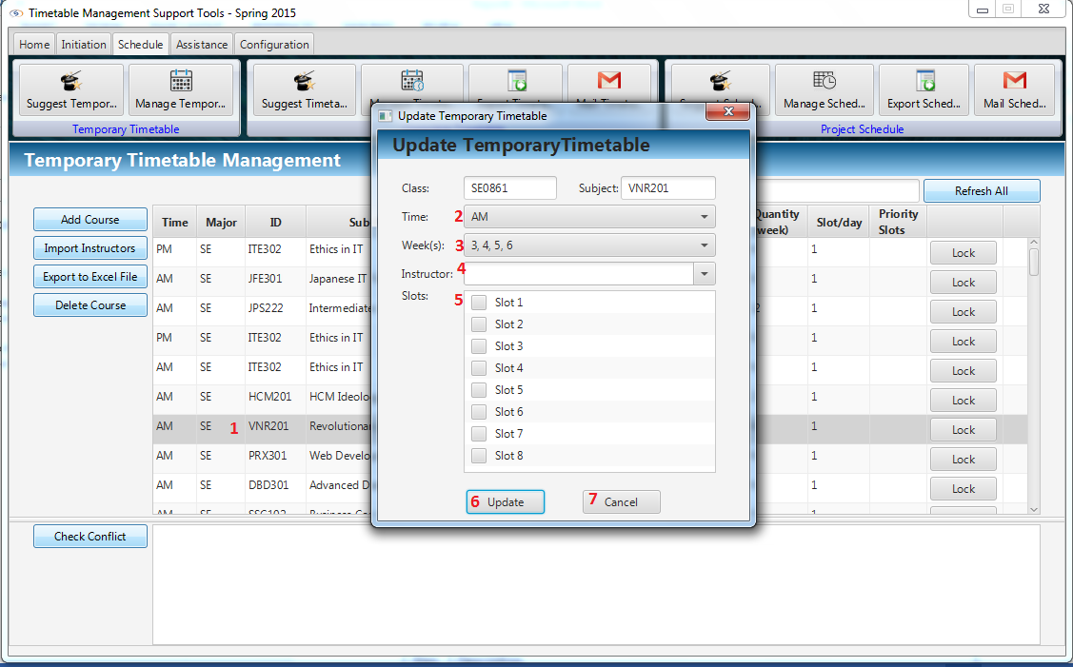

Figure : Edit Temporary Data

|  |  |
| --- | --- |
| **Step** | **Description** |
| 1 | Double clicks on a non-clock row of table |
| 2 | Select Time by Combo box |
| 3 | Select Week by Combo box |
| 4 | Select Instructor by Combo box |
| 5 | Check slots that course will study |
| 6 | Click “Update” button to update changed information |
| 7 | Click “Close” button to close window |

### View Temporary Data

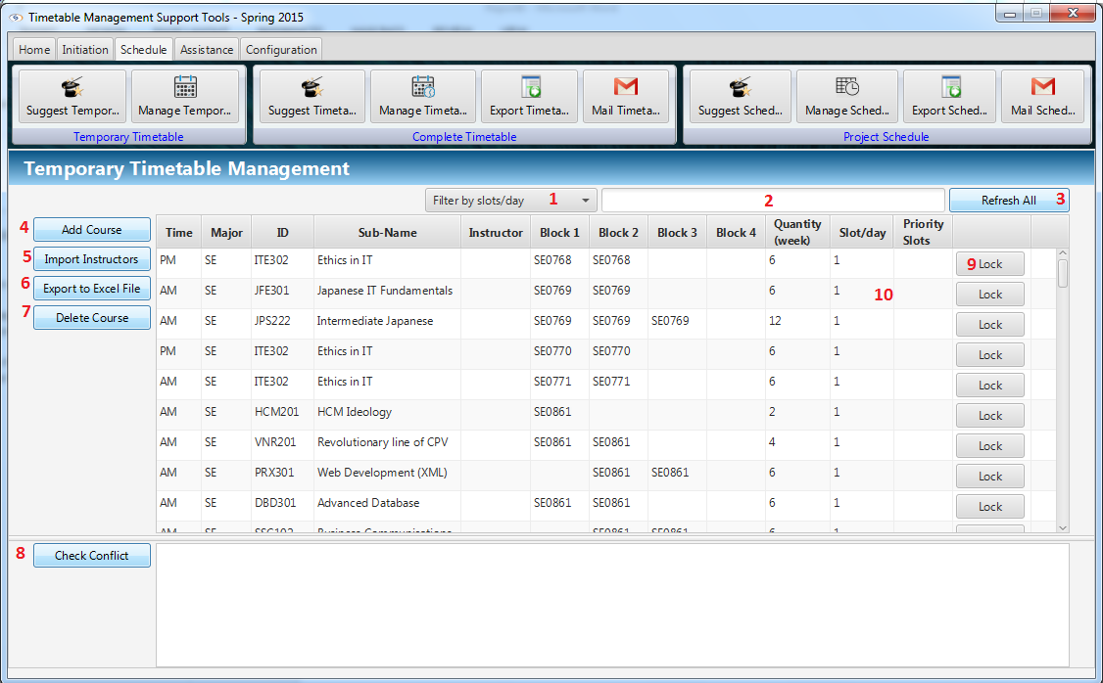

Figure : View Temporary Data

|  |  |
| --- | --- |
| **Step** | **Description** |
| 1 | Filter slot/day by combo box |
| 2 | Filter by attributes |
| 3 | Click “Refresh” button to reshow data |
| 4 | Click “Add Course” to add new course |
| 5 | Click “Import Instructors” to import instructor file |
| 6 | Click “Export to excel file” to export temporary timetable |
| 7 | Delete course |
| 8 | Check “Check Conflict” button to check conflict |
| 9 | Click “Clock” button to lock the row |
| 10 | Double clicks to row to edit data |

### Add Course

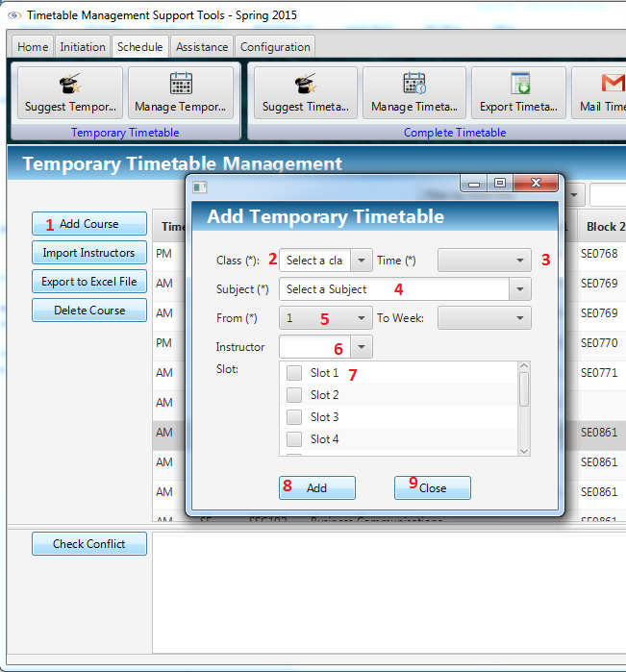

Figure : Add Course

|  |  |
| --- | --- |
| **Step** | **Description** |
| 1 | Click “Add Course” button |
| 2 | Select Class by combo box |
| 3 | Select time AM/PM by combo box |
| 4 | Select Subject by combo box |
| 5 | Select From week number by combo box, To week number will suggest automatically |
| 6 | Select Instructors by combo box |
| 7 | Check what slots that new course will study in |
| 8 | Click “Add” to add new course |
| 9 | Click “Close” to close window |

### Export to Excel

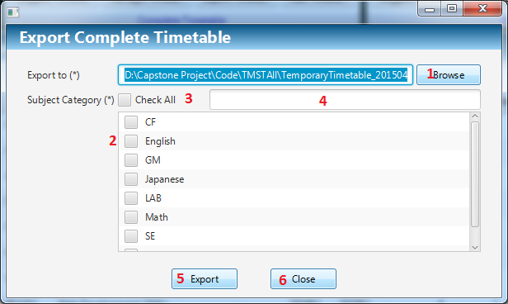

Figure : Export to Excel

|  |  |
| --- | --- |
| **Step** | **Description** |
| 1 | Click “Browse” button to select path to export |
| 2 | Check category checkboxes need to export |
| 3 | Check “Check All” button to check all category |
| 4 | Search category |
| 5 | Click “Export” button to export to selected location |
| 6 | Click “Close” button to close window |

### Create Complete

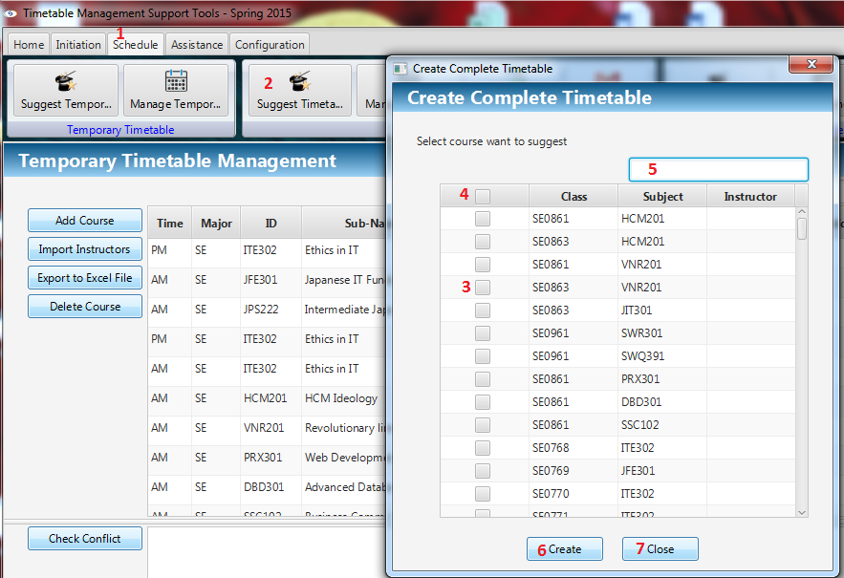

Figure : Create Complete

|  |  |
| --- | --- |
| **Step** | **Description** |
| 1 | Click “Schedule” Tab |
| 2 | Click “Suggest Timetable” button |
| 3 | Select classes will be suggested |
| 4 | Click top checkbox to check all classes |
| 5 | Filter data by Class, Subject, Instructor |
| 6 | Click “Create” button to create Complete timetable |
| 7 | Click “Close” button to close window |

### Show Complete

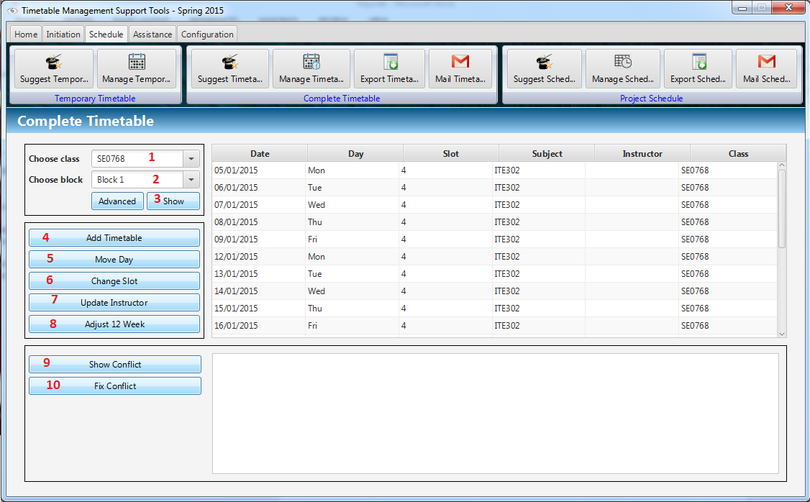

Figure : Show Complete

|  |  |
| --- | --- |
| **Step** | **Description** |
| 1 | Select Class by combo box |
| 2 | Select Block by combo box |
| 3 | Click “Show” button |
| 4 | Click “Add Timetable” button to add more timetable |
| 5 | Click “Move Day” button to move day |
| 6 | Click “Change Slot” button to change slot |
| 7 | Click “Update Instructor” to update instructor for a timetable |
| 9 | Click “Show conflict” to show conflict in time table |
| 10 | Click “Fix conflict” to fix conflict in timetable |

### Edit Complete

#### Add Time Table

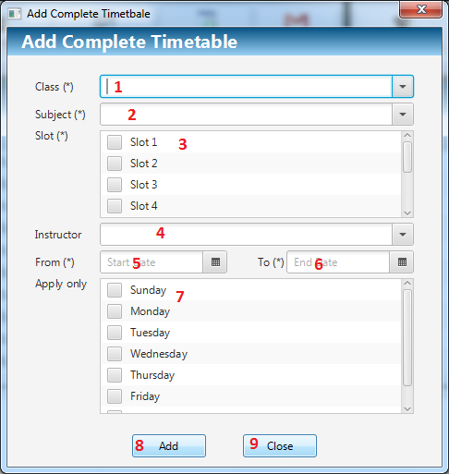

Figure : Add Time Table

|  |  |
| --- | --- |
| **Step** | **Description** |
| 1 | Select Class by combo box |
| 2 | Select Subject by combo box |
| 3 | Check what slots that new course will be studied in |
| 4 | Select Instructors by combo box |
| 5 | Select From day by Date picker |
| 6 | Select End day by Date picker |
| 7 | Check days in week will be studied on |
| 8 | Click “Add” to change information |
| 9 | Click “Close” to close the window |

#### Move Day

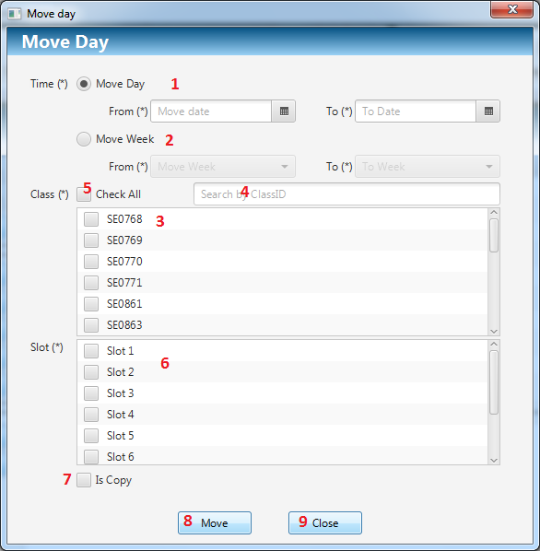

Figure : Move Day

|  |  |
| --- | --- |
| **Step** | **Description** |
| 1 | Select “Move day” to move day of course by radio button |
| 2 | Select “Move week” to move week of course by radio button |
| 3 | Select classes by checkbox |
| 4 | Filter class by text field |
| 5 | Select all Class by check All checkbox |
| 6 | Select slots by checkbox |
| 7 | Check “isCopy” to move to another day but not removing current day |
| 8 | Click “Move” button to move day |
| 9 | Click “Close” to close the window |

#### Change Slot

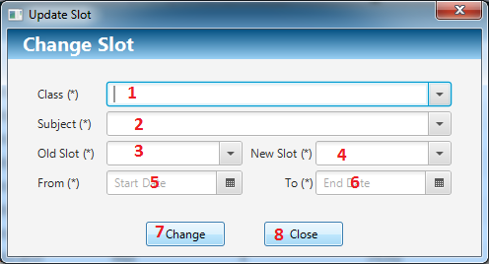

Figure : Change Slot

|  |  |
| --- | --- |
| **Step** | **Description** |
| 1 | Select Class by combo box |
| 2 | Select Subject by combo box |
| 3 | Select new slot by combo box |
| 4 | Select old slot by combo box |
| 5 | Select From day by Date picker |
| 6 | Select End day by Date picker |
| 7 | Click “Change” button to move day |
| 8 | Click “Close” to close the window |

#### Update Instructor

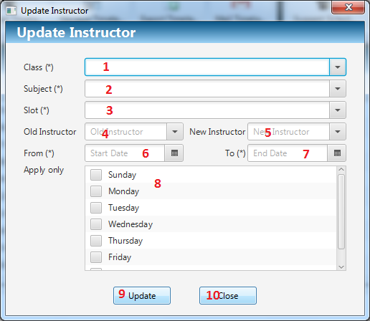

Figure : Update Instructor

|  |  |
| --- | --- |
| **Step** | **Description** |
| 1 | Select Class by combo box |
| 2 | Select Subject by combo box |
| 3 | Select Slot by combo box |
| 4 | Select old Instructor by combo box |
| 5 | Select new Instructor by combo box |
| 6 | Select From day that instructor will teach by Date picker |
| 7 | Select End day that instructor will teach by Date picker |
| 8 | Select Day in week by checkbox |
| 9 | Click “Update” button to move day |
| 10 | Click “Close” to close the window |

#### Adjust 12 week

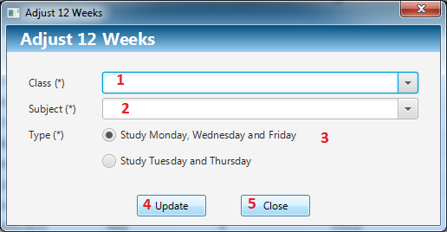

Figure : Adjust 12 week

|  |  |
| --- | --- |
| **Step** | **Description** |
| 1 | Select Class by combo box |
| 2 | Select Subject by combo box |
| 3 | Select types of days that will teach by radio button group |
| 4 | Click “Update” button to move day |
| 5 | Click “Close” to close the window |

### Export Timetable

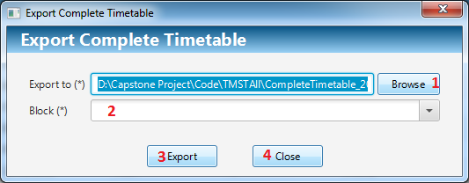

Figure : Export Timetable

|  |  |
| --- | --- |
| **Step** | **Description** |
| 1 | Click “Browse” button to select path to export |
| 2 | Select Block by Combo box |
| 3 | Click “Export” button to export to selected location |
| 4 | Click “Close” button to close window |

### Mail Timetable

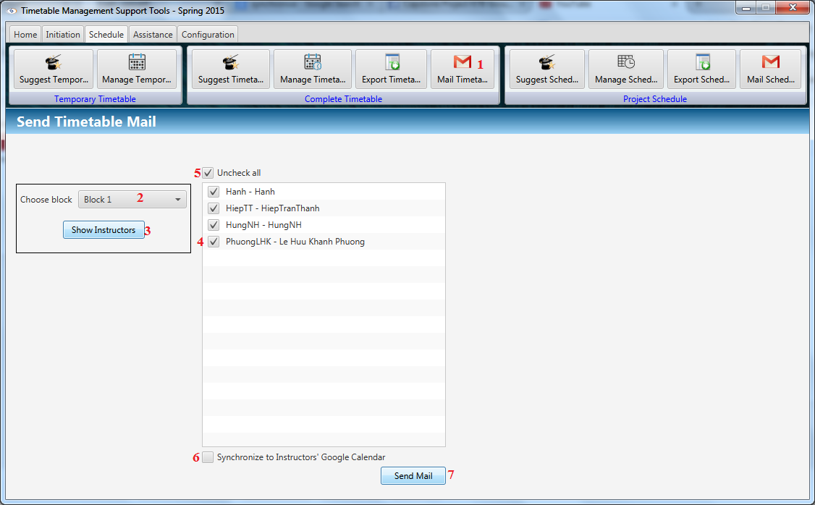

Figure : Mail Timetable

|  |  |
| --- | --- |
| **Step** | **Description** |
| 1 | Click “Mail timetable” button on Schedule |
| 2 | Select Block by Combo box |
| 3 | Click “Show Instructor” Button |
| 4 | Check instructor by checkbox |
| 5 | Check “Check all” button to check all instructors |
| 6 | Check “Synchronize to Instructor’s to Calendar” to synchronize with Google calendar |
| 7 | Click “Send Mail” button to send for selected instructors |

### Suggest Guide Project Schedule

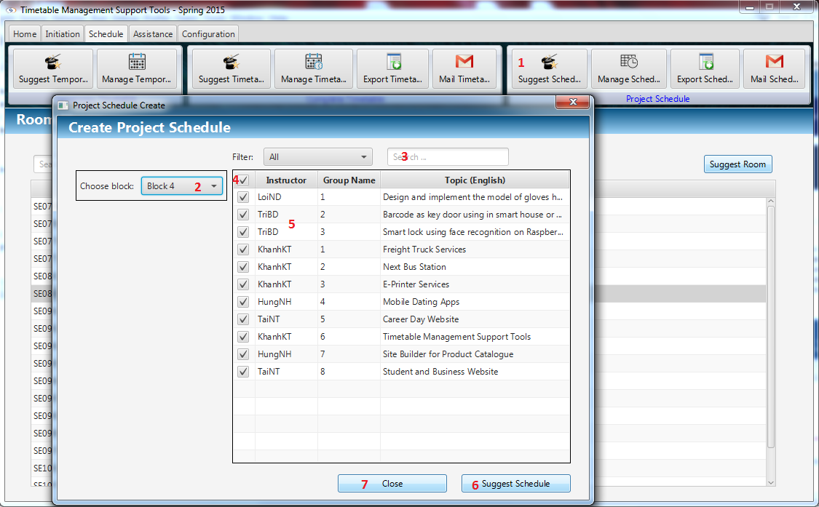

Figure : Suggest Guide Project Schedule

|  |  |
| --- | --- |
| **Step** | **Description** |
| 1 | Click “Suggest Schedule” button on Schedule Project |
| 2 | Select Block by Combo box |
| 3 | Search data by filter field |
| 4 | Check “Check all” button to check all instructors |
| 5 | Select Project by checkbox |
| 6 | Click “Suggest Schedule” button to suggest project schedule |
| 7 | Click “Close” to close the window |

### Manage Schedule

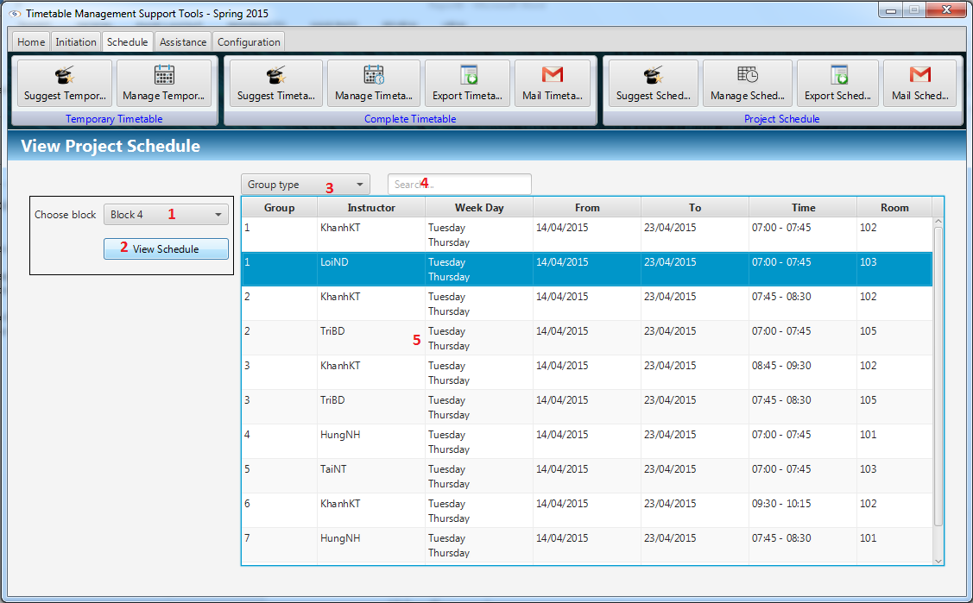

Figure : Manage Schedule

|  |  |
| --- | --- |
| **Step** | **Description** |
| 1 | Select Block by Combo box |
| 2 | Click “View Schedule” button to view |
| 3 | Schedule Selected Group Type by Combo box |
| 4 | Search data by filter field |
| 5 | Double clicks to edit data field |

### Edit Guide Project Schedule

#### Change Day

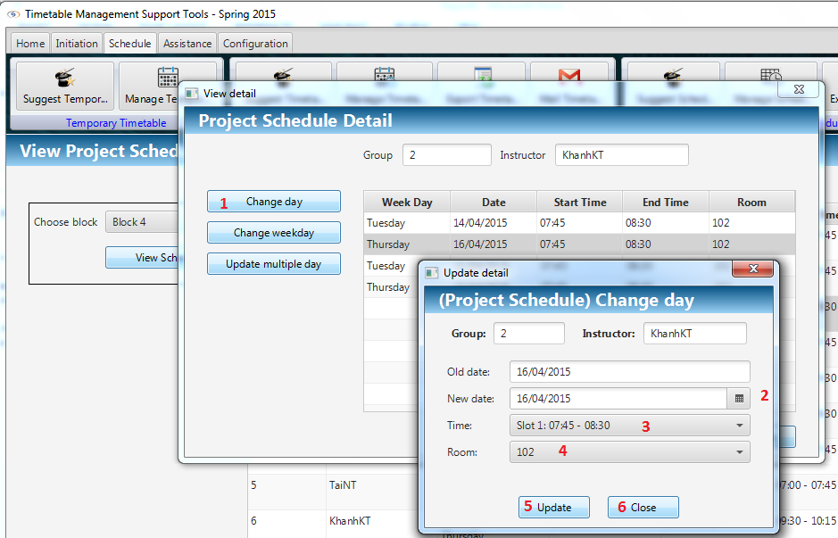

Figure : Change Day

|  |  |
| --- | --- |
| **Step** | **Description** |
| 1 | Click on “Change day” |
| 2 | Select date by day picker |
| 4 | Select time by combo box |
| 5 | Select room by combo box |
| 6 | Click “Update” button to update information |
| 7 | Click “Close” button to close window |

#### Change Week

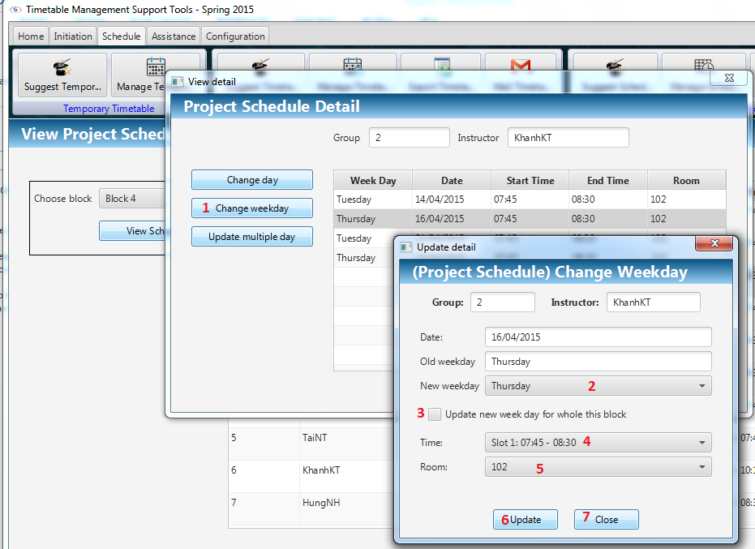

Figure : Change Week

|  |  |
| --- | --- |
| **Step** | **Description** |
| 1 | Click on “Change weekday” |
| 2 | Select new weekday by combo box |
| 3 | Stick checkbox to update week day for whole block |
| 4 | Select time by combo box |
| 5 | Select room by combo box |
| 6 | Click “Update” button to update information |
| 7 | Click “Close” button to close window |

#### Update Multiple Day

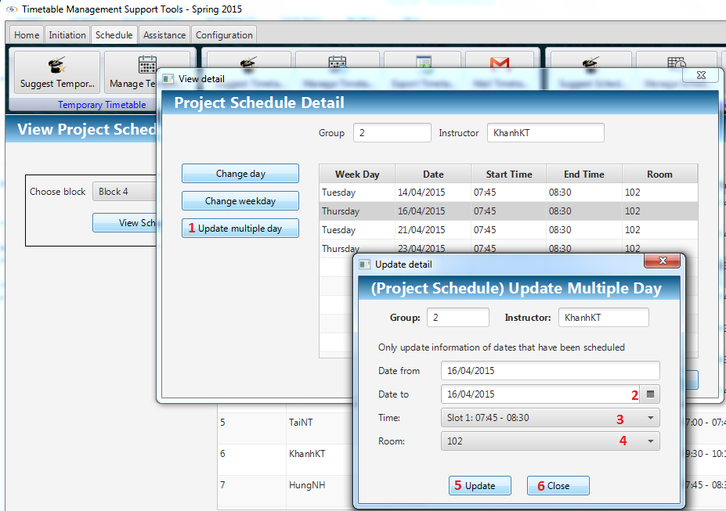

Figure : Update Multiple Day

|  |  |
| --- | --- |
| **Step** | **Description** |
| 1 | Click on “Change weekday” |
| 2 | Select new weekday by combo box |
| 3 | Stick checkbox to update week day for whole block |
| 4 | Select room by combo box |
| 5 | Click “Update” button to update information |
| 6 | Click “Close” button to close window |

### Export Guide Project Schedule

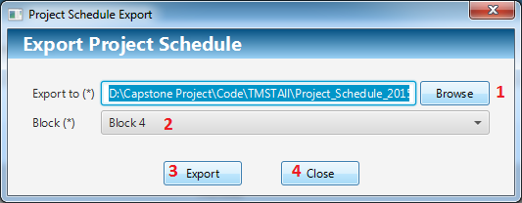

Figure : Export Guide Project Schedule

|  |  |
| --- | --- |
| **Step** | **Description** |
| 1 | Click “Browse” button to select path to export |
| 2 | Select Block by Combo box |
| 3 | Click “Export” button to export to selected location |
| 4 | Click “Close” button to close window |

### Mail Guide Project Schedule

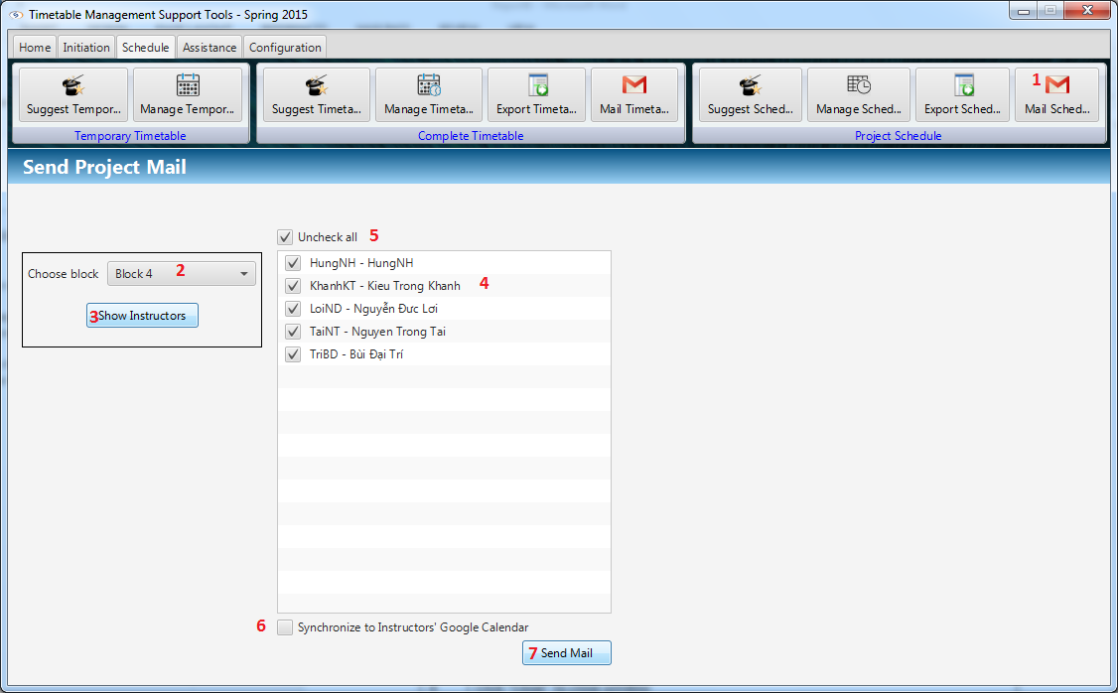

Figure : Mail Guide Project Schedule

|  |  |
| --- | --- |
| **Step** | **Description** |
| 1 | Click “Mail timetable” button on Schedule |
| 2 | Select Block by Combo box |
| 3 | Click “Show Instructor” Button |
| 4 | Check instructor by checkbox |
| 5 | Check “Check all” button to check all instructors |
| 6 | Check “Synchronize to Instructor’s to Calendar” to synchronize with Google calendar |
| 7 | Click “Send Mail” button to send for selected instructors |

### Manage Room Usage

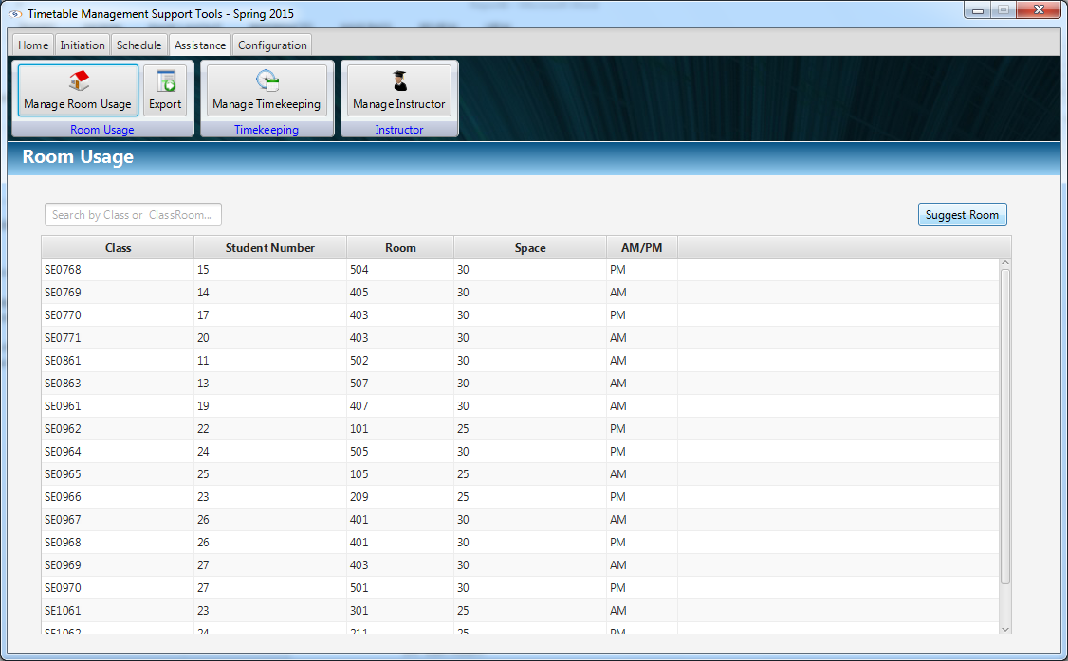

Figure : Manage Room Usage

|  |  |
| --- | --- |
| **Step** | **Description** |
| 1 | Click “Manage Room Usage” |
| 2 | Click “Suggest Room” to suggest rooms for classes |
| 3 | Search data by Class or Classroom by filter field |

### Edit Room Usage

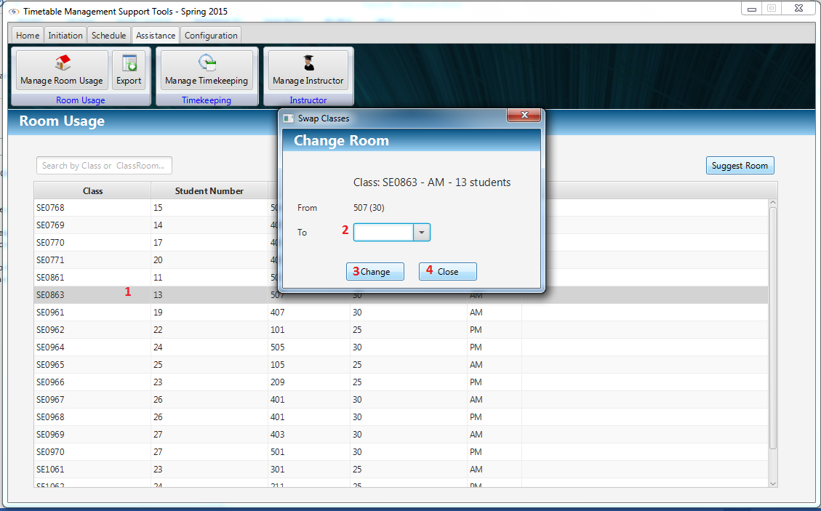

Figure : Edit Room Usage

|  |  |
| --- | --- |
| **Step** | **Description** |
| 1 | Double clicks on row on data to choose class for changing room |
| 2 | Select room by Combo box |
| 3 | Click “Change” to change room |
| 4 | Click “Close” to close window |

### Export Room Usage

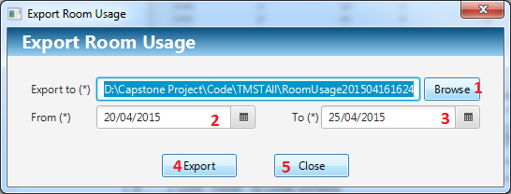

Figure : Export Room Usage

|  |  |
| --- | --- |
| **Step** | **Description** |
| 1 | Click “Browse” button to select path to export |
| 2 | Select From day by date picker |
| 3 | Select End day by date picker |
| 4 | Click “Export” button to export to selected location |
| 5 | Click “Close” button to close window |

### Calculate Timekeeping

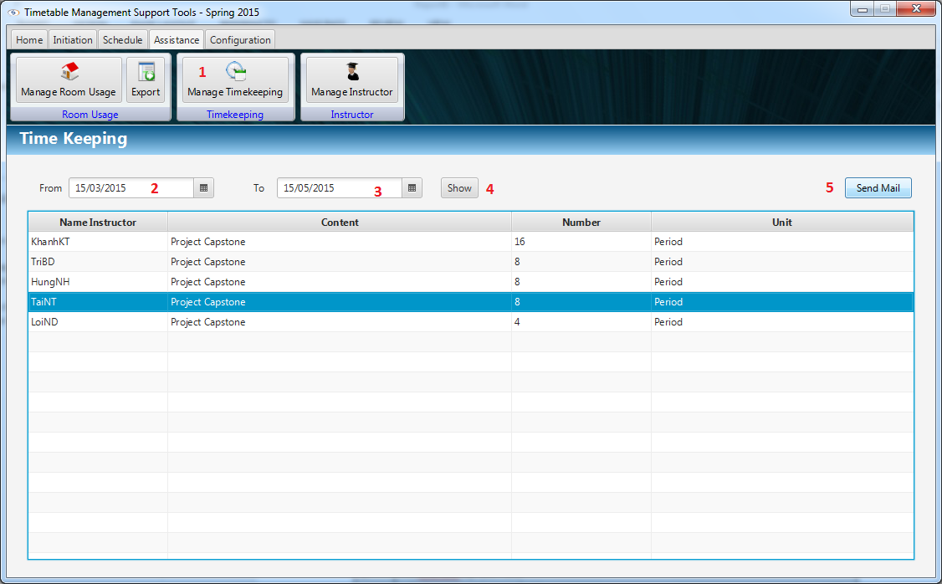

Figure : Calculate Timekeeping

|  |  |
| --- | --- |
| **Step** | **Description** |
| 1 | Click “Manage Timekeeping” button |
| 2 | Select From day by date picker |
| 3 | Select End day by date picker |
| 4 | Click “Show” button to show data filter by From day and End day |
| 5 | Click “Send Mail” button to send timekeeping |

### Email Configuration

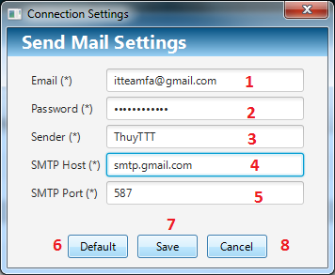

Figure : Email Configuration

|  |  |
| --- | --- |
| **Step** | **Description** |
| 1 | Fill Email by text field |
| 2 | Fill Password by text field |
| 3 | Fill Sender Name by text field |
| 4 | Fill SMTP Host by text field |
| 5 | Fill SMTP Port by text field |
| 6 | Click “Default” button to reset default values |
| 7 | Click “Save” button to save values |
| 8 | Click “Close” button to close window |

### Synchronize Configuration

#### Get JSON file

Reference: [https://developers.google.com/.../#creatingdeletingprojects](https://developers.google.com/console/help/#creatingdeletingprojects)

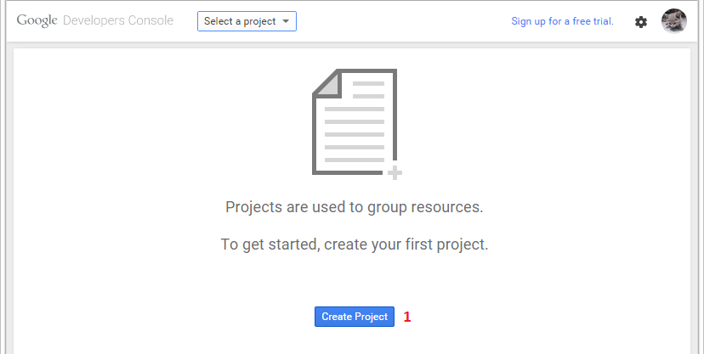

Figure : Get JSON setting - Step 1 – Create Project

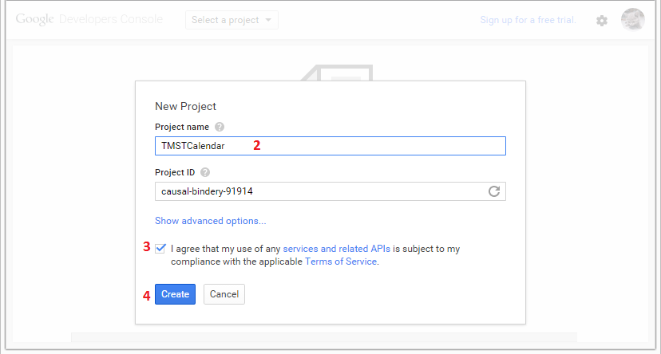

Figure : Get JSON setting - Step 2, 3, 4 – Setting name of project

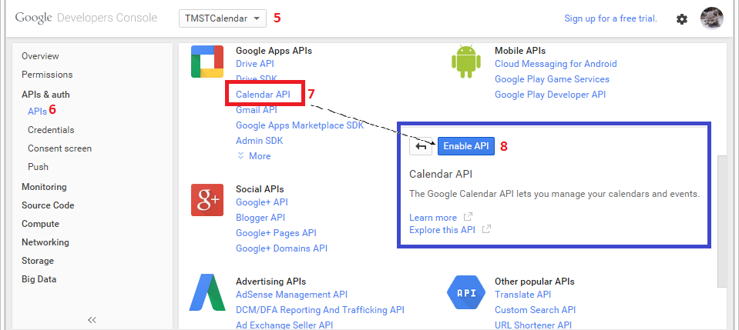

Figure : Get JSON setting – Step 5, 6, 7, 8 – Enable Calendar API

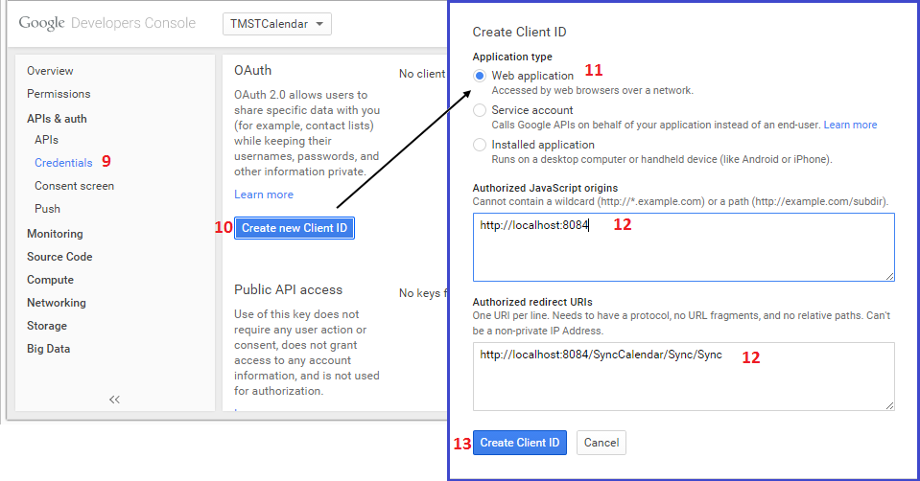

Figure : Get JSON setting – Step 9, 10, 11, 12, 13 – Create Client ID

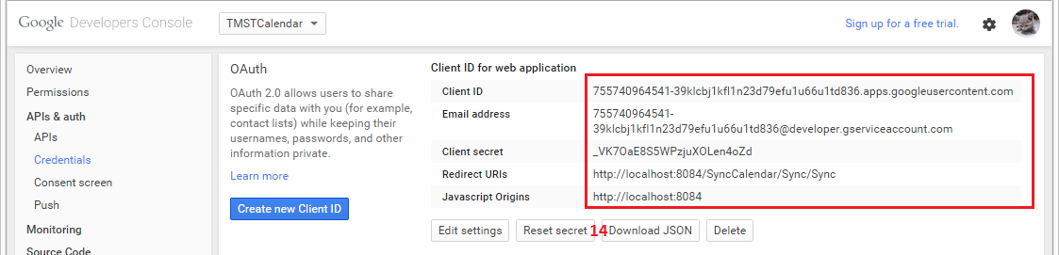

Figure : Get JSON setting – Step 14 – Download JSON file

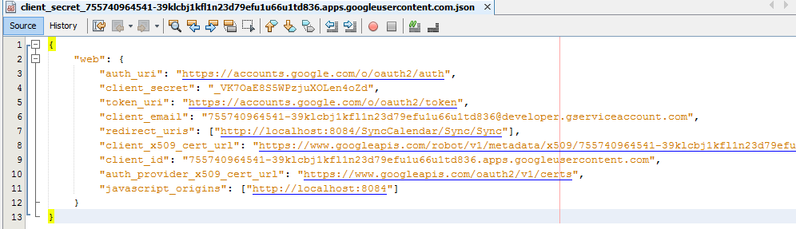

Figure : Get JSON setting – Content of JSON file

|  |  |
| --- | --- |
| **Step** | **Description** |
| 1 | Staff go <https://console.developers.google.com/project> to creating a project. |
| 2 | Fill name of project |
| 3 | Check to agree Terms of Service |
| 4 | Click “Create” button to finish create. |
| 5 | Choose project on combo box. |
| 6 | Click “APIs” in “APIs & auth” link |
| 7 | Click “Calendar API” link |
| 8 | Click “Enable API” to enable calendar API. |
| 9 | Click “Credentials” on left panel link |
| 10 | Click “Create new Client ID” to open window create |
| 11 | Select “Web application” |
| 12 | Enter link JavaScript origins (Optional) and Enter “Authorized redirect URIs” link |
| 13 | Click “Create Client ID” button. |
| 14 | Click “Download JSON” button. |

#### Synchronize Configuration

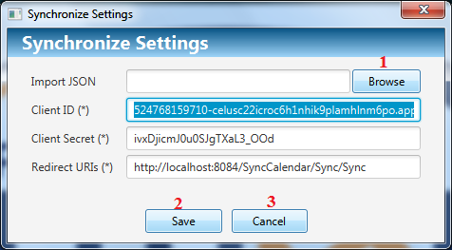

Figure : Synchronize Configuration

|  |  |
| --- | --- |
| **Step** | **Description** |
| 1 | Click “Browse” button to select JSON file created in 2.24.1. |
| 2 | Click “Save” button to save settings |
| 3 | Click “Cancel” button to close window |

# Appendix

1. Google API:

* <http://kieutrongkhanh.net/index.php/google-api/102-google-calendar-part-1>
* <http://kieutrongkhanh.net/index.php/google-api/106-google-calendar-part-2>
* <http://kieutrongkhanh.net/index.php/google-api/108-google-calendar-part-3>
* <https://developers.google.com/maps/documentation/javascript/tutorial>

1. Ribbon menu

* <https://introjava.wordpress.com/2012/04/08/java-fx-2-ribbon-menu/>

1. JavaFX 8 Tutorial

* <http://code.makery.ch/library/javafx-8-tutorial/>